JAMESTOWN ZONING BOARD OF REVIEW

Minutes of the January 26, 2016 Meeting

A regular meeting of the Jamestown Zoning Board of Review was held at the Jamestown Town Hall, 93 Narragansett Avenue. The Chairman called the meeting to order at 7:00 p.m. The stenographer called the roll and noted the following members present:

Richard Boren
Joseph Logan
Dean Wagner
Richard Cribb
Judith Bell
Terence Livingston

Also present: Brenda Hanna, Stenographer
Chris Costa, Zoning Officer
Pat Westall, Zoning Clerk
Wyatt Brochu, Counsel

MINUTES

Minutes of December 15, 2015

A motion was made by Joseph Logan and seconded by Richard Cribb to accept the minutes of the December 15, 2015 meeting as presented.

The motion carried by a vote of 5 –0.

Richard Boren, Joseph Logan, Dean Wagner, Richard Cribb, and Judith Bell voted in favor of the motion.

Terence Livingston was not seated and Edward Gromada was absent.

CORRESPONDENCE

A letter from the Town Counsel informing the Chair that Edward Gromada, Joseph Logan, Dean Wagner, and Terence Livingston were reappointed to the Zoning Board.

An Entry of Appearance from W. Mark Russo, Esq. in re: Appeal of David S. Martin et al.

A letter dated Jan. 7, 2016 from Robert E. Flaherty, Esq. re: 1095 E. Shore Rd.

A letter dated Jan. 26, 2016 from Christian S. Infantolino, Esq. requesting a continuance of Fowler’s Rock.

Fowler’s Rock

A motion was made by Joseph Logan and seconded by Richard Cribb to continue the application of Fowler’s Rock to the Feb. 23, 2016 meeting.

The motion carried by a vote of 5 –0.

Richard Boren, Joseph Logan, Dean Wagner, Richard Cribb, and Judith Bell voted in favor of the motion.

Terence Livingston was not seated and Edward Gromada was absent.

A letter dated Jan. 26, 2016 from Christian S. Infantolino, Esq. requesting a continuance of Jamestown Boat Yard.

Jamestown Boat Yard

A motion was made by Joseph Logan and seconded by Richard Cribb to continue the application of Jamestown Boat Yard to the Feb. 23, 2016 meeting.

The motion carried by a vote of 5 –0.

Richard Boren, Joseph Logan, Dean Wagner, Richard Cribb, and Judith Bell voted in favor of the motion.

Terence Livingston was not seated and Edward Gromada was absent.

OLD BUSINESS

Stearns Farms

STATE OF RHOSE ISLAND AND PROVIDENCE PLANTATIONS
TOWN OF JAMESTOWN

IN THE MATTER OF:

APPEAL OF DAVID S. MARTIN; JANICE :
MARTIN; STEARNS FARMS REALTY, LLC : JAMESTOWN ZONING
BOARD OF REVIEW

Decision of the Town of Jamestown Zoning Board of Review

- Introduction.

On November 12, 2015, the Appellants filed an appeal from the issuance of a building permit on February 15, 2013 to the Lischios. The Appellants are asking the Zoning Board of Review to require the Lischios to seek the approval of the Zoning Board to construct those improvements completed in 2013. The Appellants further request that the Zoning Board of Review overturn the issuance of the building permit and declare the February 15, 2013 building permit and the certificate of occupancy void.

On or about December 3 or December 4, 2015, the Lischios filed a Motion to Dismiss the Appeal on the basis that the appeal is out of time and/or a zoning enforcement action can only be prosecuted by a Town through its’ Solicitor. The Motion to Dismiss further alleges that the Zoning Board of Review has no jurisdiction over the Martin appeal if not made within thirty (30) days of the time when the Appellant becomes chargeable with knowledge of the decision.

The Appellants have filed a Memorandum in Opposition to the Motion to Dismiss.

- Standard of Review.

A Motion to Dismiss permits this Zoning Board of Review to dismiss an appeal for failure to state a claim upon which relief may be granted or for lack of subject matter jurisdiction. The sole function of a Motion to Dismiss “is to test the sufficiency of the appeal”. See Ho-Rath v. Rhode Island Hospital, 89 A.3d 806 (R.I. 2014). In deciding a Motion to Dismiss, the zoning board is to confine its’ review to the four corners of the appeal and must assume all allegations are true, resolving any doubt in the Appellants favor. See Narragansett Electric Company v. Minardi, 21 A.3d 274 (R.I. 2011). A Zoning Board of Review may grant a motion to dismiss when it is clear beyond a reasonable doubt that the Appellant would not be entitled to relief from the zoning board under any set of facts that could be proven in support of the Appellants claim. See School Committee v. Chaffee, 89 A.3d 778 (R.I. 2014).

A Motion to Dismiss also permits dismissal for lack of subject matter jurisdiction. Such a motion questions the zoning board’s authority to adjudicate a particular controversy before it. See Boyer v. Bedrosian, 57 A.3d 259 (R.I. 2012). When ruling on such a motion, a court or zoning board is not limited to the face of the pleadings. A court or zoning board may consider any evidence it deems necessary to settle the jurisdictional question. A claim of lack of subject matter jurisdiction may be raised at any time by the parties or by the court sua sponte. See Sidell v. Sidell, 18 A.3d 499 (R.I. 2011).

If, however, matters outside the pleading are presented to and not excluded by the zoning board, the motion shall be treated as one for Summary Judgment and disposed of accordingly, and all parties shall be given reasonable opportunity to present all material pertinent to the motion. Here, both parties have presented certain portions of the pleadings and both parties have been given reasonable opportunity to respond.

III. Facts and Allegations.

The facts and allegations set forth herein are taken solely from the November 12, 2015 appeal of the Martins and Stearns Farms Realty, LLC and those limited statements the Martins reference in their Memorandum.

On November 12, 2015, the Martins and Stearns Farms Realty, LLC filed an appeal from the issuance of a building permit on February 15, 2013 to the Lischios.

On January 12, 2013, the Lischios filed an application for a building permit to construct a second floor guest quarters above the Lischios garage.

On February 15, 2013, the building official approved the January 12, 2013 permit application, and construction commenced thereafter. At the time, the zoning official failed to issue a zoning certificate and publish the zoning certificate in the newspaper.

In spite of lack of publication, in February 2013, Mr. Martin learned of the planned construction in which he was told that the project entailed the conversion of the second floor of the garage into guest quarters.

In late March 2013, Mr. Martin met with the building official and discussed the 1986 variance, which Mr. Martin claimed to the zoning official was at odds with the 2013 building permit.

On September 6, 2013, the building official issued a certificate of occupancy.

In 2014, Mr. Martin filed suit in Newport County Superior Court to declare that the February 2013 building permit was void.

The Martin appeal acknowledges that “With respect to the issuance of a building permit, which is not required to be recorded and was not in this case, the Rhode Island Supreme Court has stated that the time period within which to file an appeal begins to run when the Appellant becomes chargeable with knowledge of the decision from which he seeks to appeal.” Sousa v. Town of Coventry, 774 A.2d 812 (R.I. 2001).

The Martin appeal further acknowledges that R.I.G.L. § 45-24-64 provides that an appeal shall be taken within a reasonable time of the date of the recording of the decision of the zoning official.

Mr. Martin alleges in his appeal that although he learned of the issuance of the building permit in 2013, he did not learn the full story until Mary Meagher was deposed on November 3, 2015. As previously set forth, the relief being sought by the Martins is to overturn the issuance of the February 2013 building permit, declare the February 2013 building permit and the September 6, 2013 certificate of occupancy void, and require, after the fact that the garage has been built, to now seek zoning board approval to construct the two and one-half year old existing garage with guest quarters.

IV. The Issues Addressed in the Lischios Motion to Dismiss and Accompanying Memorandum.

The Lischios filed a Motion to Dismiss the Martin appeal on the basis that the appeal is out of time and/or a zoning enforcement action can only be prosecuted by a Town through its’ Solicitor.

The Motion to Dismiss further alleges that the Zoning Board of Review has no jurisdiction over the Martin appeal if the appeal is not made within thirty days of the time when the Appellants become chargeable with knowledge of the decision. See Hardy v. Zoning Board of Coventry, 321 A.2d 298 (R.I. 1984).

The Motion to Dismiss further alleges that if the Martins and Stearn have not filed a timely appeal, there can be no consideration of whether the Lischios did or did not need zoning board approval in the first instance.

The Motion to Dismiss further alleges that this is not an appeal to the Zoning Board of Review before or during construction, but the appeal is seeking to declare a building permit and certificate of occupancy void.

Finally, the Motion to Dismiss alleges that the Martins have no standing to bring their appeal and any such action can only be brought in the state courts by the Town Solicitor.

V. The Issues Addressed in the Martin/Stearns Farm Realty, LLC Memorandum.

The Appellants allege in the first instance that the unusual circumstances which will lead the Zoning Board of Review to conclude that the appeal is timely include the secret, ex-parte collusion between town officials from fairly carrying out his duties.

The Appellants further allege that the failure of the Zoning Official to issue a zoning certificate and failure to publish the zoning certificate is jurisdictional and vitiates the entire issue of timeliness.

The Appellants further allege that the doctrine of equitable tolling applies to halt any time limitation period.

Finally, the Appellants allege that their appeal is not in the nature of declaratory judgment, but is a request under R.I.G.L. § 45-24-68 for the Zoning Board of Review to reverse the Zoning Official’s decision to issue a building permit.

VI. Overriding Issue.

Notwithstanding the multiple issues raised by the Appellants, does the 2 ½ year delay preclude the Zoning Board of Review from hearing the appeal?
VII. Zoning Ordinances.

Section 82-401. Building Permit Required. No structure shall hereafter be erected, enlarged, or relocated until a permit authorizing the same shall have been issued by the zoning enforcement officer.

Section 82-402. Zoning Certificates. The zoning certificate shall be issued on the basis of the application and accompanying plans and shall authorize only the use, arrangement, and construction set forth in approved plans and applications. A record of all applications, plans, and zoning certificates shall be kept on file in the office of the zoning enforcement officer and shall be available for public inspection during regular office hours.

Section 82-403. Publication of Zoning Certificates. The zoning enforcement officer shall publish weekly a list of all zoning certificates in a newspaper of general circulation in Jamestown.

Section 82-408. Appeal of a Decision of the Zoning Enforcement Officer. Any person, group of persons, or corporation, aggrieved by a decision of the zoning enforcement officer concerning this ordinance, may file an appeal in accordance with the provisions of Article 5 of this ordinance.

Section 82-503. Procedures for Appeals, Special Use Permits and Variances.
A. Appeals to the zoning board may be taken by any person aggrieved by an officer, department, board or bureau affected by any decision of the zoning enforcement officer and the enforcement of this ordinance. Such appeal shall be taken within thirty days as provided by the rules of the zoning board by filing with the zoning enforcement officer and with the board a Notice of Appeal specifying the grounds thereof.

VIII. Timeliness of Appeal.

As a matter of law, is the Martin appeal out of time, and if so, does that deprive the Zoning Board of Review of jurisdiction from hearing the merits of the appeal?

On February 15, 2013, the zoning enforcement officer approved the January 12, 2013 building permit. The zoning enforcement official did not comply with Section 84-203 by publishing the zoning certificate in a newspaper.

However, in February 2013, the Martins learned of the planned construction. In March 2013, Mr. Martin met with the zoning official, learned of the building permit, and Mr. Martin claimed that the building permit was at odds with the 1986 variance granted. The Martins took no appeal at that time.

On September 6, 2013, a certificate of occupancy was issued. The Martins took no appeal at that time.

In October 2014, the Martins filed suit in Superior Court seeking to declare that the 2013 building permit was void. The Martins took no appeal at that time.

On July 29, 2015, in the Superior Court lawsuit, Fred Brown was deposed. The Martins took no appeal at that time.

On November 3, 2015, in the Superior Court lawsuit, Mary Meagher was deposed. Nine days later, this appeal followed.

In the Rhode Island Supreme Court case of Sousa v. Town of Coventry, 774 A.2d 812 (R.I. 2001), on July 22, 1997, Sprint applied for a building permit for the construction of a telecommunications tower on town property. The building permit was issued on July 29, 1997. Rather than file an appeal to the Zoning Board of Review, the Sousas filed suit in Superior Court on September 26, 1997 seeking to revoke Sprint’s building permit. The trial judge granted summary judgment on behalf of Sprint and the Sousas appealed to the Supreme Court. The Sousas argued in the Supreme Court that the appeal period for contesting the issue of the building permit did not begin to run until the Sousas became aware of the decision to issue the building permit and they did not become aware of the issuance of the building permit until cement trucks appeared on September 16, 1997. Thus, the Sousas argued that their Complaint filed on September 26, 1997 was well within the thirty day time period provided for contesting the issuance of the building permit. The Supreme Court first stated that the thirty day time period for review of an administrative officer’s decision to issue a building permit is permissible and reasonable so long as the period begins to run at the time the Plaintiff “becomes chargeable with knowledge of the decision from which he seeks to appeal.” (emphasis added) In the Sousa case, the Rhode Island Supreme Court held that the Sousas had constructive notice that a building permit would be issued and that they had an obligation to periodically inspect the public records for the issue of a building permit for the telecommunications tower. Therefore, the Sousas Complaint filed on September 26, 1997 seeking to challenge the issuance of the building permit was untimely.
Here, the Martins learned of the planned construction in February 2013. In March 2013, the Martins met with the building official, learned of the building permit, and claimed that the building permit was at odds with the 1986 variance granted. Certainly, by March 2013, the Martins were chargeable with knowledge. The Martins took no appeal.

Since the certificate of occupancy was issued on September 6, 2013, and the Martins were abutters to the Lischios, the Martins certainly had knowledge between March 2013 and September 2013 of the construction. The Martins took no appeal during that six month period.

In October 2014, the Martins chose as their sole remedy at that time to file suit in Superior Court seeking to declare that the February 2013 building permit was void. The Martins certainly could have chosen to appeal to the Zoning Board of Review at that time. The Martins took no appeal.

There are no Rhode Island Supreme Court decisions that hold that an Appellant can wait until the Appellant learns “the full story” before filing an appeal. Simply because the Appellants learned additional information from the depositions of Fred Brown in July 2015 and Mary Meagher in November 2015 does not extend the time for appeal from the dates in 2013 that Appellants had actual knowledge of the building permit, construction, the certificate of occupancy, and the issue presently on appeal regarding the 1986 variance.

Even assuming that in April 2013 Brown and Meagher were “conspiring” to appease Mr. Martin and Mr. Martin was “appeased”, whether Mr. Martin knew or did not know of the alleged actions of Brown and Meagher, Mr. Martin had already met with Mr. Brown, reviewed the building permit, and claimed to Mr. Brown that the building permit was at odds with the 1986 variance granted. At that time, Mr. Martin had actual knowledge of the building permit and he is so charged with that knowledge.

As set forth in the Standard of Review section of this decision, if matters are presented outside the appeal pleading and are not excluded by the zoning board, the Motion to Dismiss shall be treated as a Motion for Summary Judgment and disposed of accordingly. As the Rhode Island Supreme Court has said in Coia v. Stephano. 511 A.2d 980 (R.I. 1986), a Motion to Dismiss, based upon matters outside the pleadings will be treated as a Motion for Summary Judgment under this rule. When there is no genuine issue of material fact and the moving party is

entitled to judgment as a matter of law, summary judgment is properly entered. See Tangleridge Development Copr. V. Joslin, 570 A.2d 1109 (R.I. 1990), Alfano v. Landers, 585 A.2d 651 (R.I. 1991).

With the Lischios Memorandum of Law, they attach a booklet of exhibits. Exhibit # 3 is a letter dated April 10, 2013 from David Martin to Diane Lischio outlining all of the issues he has now addressed in this appeal. As Mr. Martin states in the third paragraph of his letter “That being said, however, there is little question in my mind that a building permit should not have been issued to your parents for the conversion of the garage with its’ attic that is now underway.”

On April 10, 2015, Mr. Martin was deposed under oath in the Superior Court suit. During the deposition, Mr. Martin was represented by counsel. The following colloquy took place that is set forth in Exhibit # 12:

Question: My question is: Instead of filing this lawsuit, why didn’t you
appeal because you have mentioned it so many times in the past?

Answer: I had, subsequent to the initiation of the improperly issued
permit, determined that there was a time restraint to appeal to the Town on building permits. And I don’t remember the deadline, but there’s a certain period of time in which an aggrieved party can appeal a zoning permit. And that time limit to my knowledge has expired.

Question: The time limit on the zoning appeal had passed?

Answer: To my knowledge yes.

The Appellants are chargeable with knowledge of the building permit in the year 2013.

IX. The Failure to Issue a Zoning Certificate and Publication.

In the Appellants’ Memorandum, they argue that the failure to issue a zoning certificate and failure to publish that zoning certificate before issuing a building permit on February 15, 2013 is jurisdictional and vitiates the entire issue of timeliness.
For the above proposition, the Appellants cite L.A. Ray Realty v. Town Council of Cumberland, 603 A.2d 311 (R.I. 1992) and Town of Johnston v. Pezza, 723 A.2d 278 (R.I. 1999).

In L.A. Ray Realty, the Town Council failed to give notice of a proposed amendment for changes to minimum lot sizes. The Rhode Island Supreme Court held that the purpose of notice requirements, whether by publication or individual notice, is to give those interested an opportunity to express their opinions. Such public notice is a jurisdictional prerequisite.

In Town of Johnston v. Pezza, a building official issued a permit to build an asphalt plan without a site plan. A subsequent building official rescinded the permit. The Rhode Island Supreme Court upheld the second building official since it found that site plan requirements were substantive and not a mere procedural exercise.

The issues here for determination are whether the issuance of the building permit constitutes public notice and vitiates the need for a zoning certificate and publication and whether what occurred in this case is procedural or substantive.

It is well established that zoning certificates are not legally binding, Parker v. Byrne, 966 A.2d 627 (R.I. 2010) and do not create any enforceable rights, Tompkins v. Zoning Board of Review of Town of Little Compton, 2003 RI Super. Lexis 133 (2003).

Likewise, the sole purpose of publication of zoning certificates is to give the public notice. In this case, the Appellants had notice almost immediately after the issuance of the building permit.

A review of Article 4 of the Zoning Ordinance clearly establishes that the building permit is the operative document.

The failure to issue a zoning certificate and publication of that zoning certificate does not relieve the Appellants from appealing in a timely manner once they are charged with knowledge of the building permit.

X. Does the Doctrine of Equitable Tolling Apply to This Case, Such That the Appeal is Timely?

First, the Appellants’ reliance on Johnson v. Newport County Chapter for Retarded Citizens, 799 A.2d 289 (R.I. 2002) is misplaced. In the Johnson case, the doctrine was rejected by the Court, but the court held that the doctrine may be applicable in certain circumstances when the Plaintiff may be found to be of unsound mind.

In Rivera v. Employees Retirement System of RI, 70 A.3d 905 (R.I. 2013), an appeal to the state retirement board must be taken within thirty days of receipt of the notice of the decision. The notice postmark was May 21, 2008, but Plaintiff’s affidavit said receipt was May 29, 2008 and appeal filed June 27, 2008. Thus, the appeal was either filed timely if receipt was on May 29, 2008, or was filed thirty-seven days after notice. The Rhode Island Supreme Court held this was a rather unusual case and the trial judge should have tolled the thirty day deadline.

The Doctrine of Equitable Tolling does not apply in this case.

XI. Decision.

It is the decision of this Zoning Board of Review that the Martin appeal is untimely and that the Lischios Motion to Dismiss, whether treated as a Motion to Dismiss or Motion for Summary Judgment, is granted based upon the untimeliness. The failure to issue a zoning certificate and publication does not vitiate untimeliness. Likewise, the Doctrine of Equitable Tolling is not applicable to the facts set forth.

Since the Martin appeal is not timely, this board does not need to address the issues as to whether the Appellants have standing to file this appeal and whether the Zoning Board of Review has jurisdiction to hear and decide declaratory judgment actions.
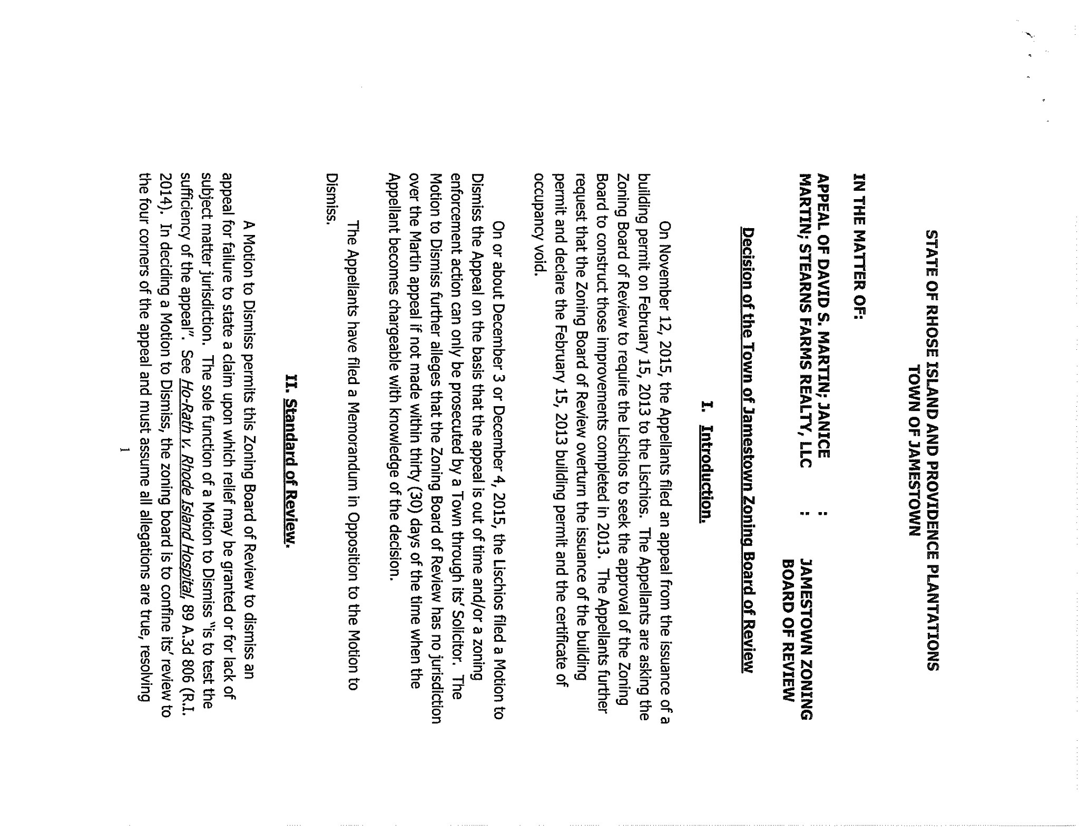

The motion was made by Richard Boren and seconded by Richard Cribb.

The motion carried by a vote of 5 –0.

Richard Boren, Joseph Logan, Richard Cribb, Judith Bell, and Terence Livingston voted in favor of the motion.

Dean Wagner was not seated and Edward Gromada was absent.

NEW BUSINESS

Gromada

A motion was made by Joseph Logan and seconded by Dean Wagner to grant request of Edward & Madeleine Gromada, whose property is located at 30 Melrose Ave., and further identified as Assessor’s Plat 8, Lot 580 for a variance from Article 3, Section 2 (District Dimensional Regulation)to construct a front porch 19’8 from the front lot line (same as existing front stoop and stairs) and a second story on the existing house that is 23’8 from the front lot line where 30’ is required.

This Board has determined that this application does satisfy the requirements of ARTICLE 6, SECTION 600, SECTION 606, and SECTION 607, PARAGRAPH 2.

This project must be constructed in strict accordance with the site and building plans duly approved by this Board.

This motion is based on the following findings of fact:

- Said property is located in a R20 zone and contains 13,000 sq. ft.
- The purposed plan meets the lot coverage requirement.
- The foot print will not extend into the setback in front more than the existing stoop (19’8”). Other setbacks are in compliance.
- There were no objectors.
- The style is similar to neighborhood houses.

A motion was made by Joseph Logan and seconded by Dean Wagner to continue the application of Jamestown Boat Yard to the Feb. 23, 2016 meeting.

The motion carried by a vote of 5 –0.

Richard Boren, Joseph Logan, Dean Wagner, Richard Cribb, and Judith Bell voted in favor of the motion.

Terence Livingston was not seated and Edward Gromada was absent.

ADJOURNMENT

A motion was made and seconded to adjourn at 8:10 p.m.

The motion carried unanimously.

