TOWN COUNCIL MEETING
March 16, 2009

A regular meeting of the Jamestown Town Council was called to order at the Jamestown Town Hall, 93 Narragansett Avenue, in the Rosamond A. Tefft Council Chambers at 7:00 p.m. by Council President Julio J. DiGiando. The following members were present:
Michael G. White, Vice President
Barbara A. Szepatowski
absent: William A. Kelly
Robert W. Sutton, Jr.

also present:
Bruce R. Keiser, Town Administrator
Peter D. Ruggiero Town Solicitor
Arlene D. Petit, Town Clerk

AWARDS, PRESENTATIONS AND ACKNOWLEDGMENTS

None

COUNCIL SITTING AS ALCOHOLIC BEVERAGE LICENSING BOARD
All approvals for licenses and permits are subject to the resolution of debts, taxes and appropriate signatures as well as, when applicable, proof of insurance.

None

CONSENT AGENDA
An item on the Consent Agenda need not be removed for simple clarification or correction of typographical errors. Approval of the Consent Agenda shall be equivalent to approval of each item as if it had been acted upon separately.

It was moved by Councilor White, seconded by Councilor Szepatowski to accept the Consent Agenda as presented. So unanimously voted. The Consent Agenda consisted of the following:
1) Adoption of Council minutes:
a) March 2, 2009 (regular session)
b) March 3, 2009 (work session)
2) Bills and Payroll
3) Minutes from Boards, Commissions and Committees:
a) Bike Path Design Committee (02/04/2009)
b) Town Charter Review Committee (03/04/2009)
c) Jamestown Conservation Commission (12/09/2008)
d) Jamestown Library Board of Trustees (01/06/2009, 02/17/2009)
e) Jamestown Housing Authority (01/13/2009)
4) CRMC Notices:
a) March Calendar – Amended
- Zoning Board of Review abutter notification
a) Public Hearing on March 24, 2009 at 7:30 p.m. re: Application of John Lawless Jr., whose property is located at 14 Pemberton Ave., and further identified as Tax Assessor’s Plat 8, Lot 473 for a variance from Article 3, Section 82-302 (District Dimensional Regulations) to construct a second story addition, demolish and reconstruct front porch and front steps. Said property is located in a CL zone and contains 26,405 sq. ft.
6) Proclamations & Resolutions from other Rhode Island cities and towns
a) Town of West Warwick Resolution re: in support of bills submitted by the General Assembly related to ending the filing of Caruolo actions against cities and towns
b) Town of East Greenwich Resolution re: support of certain articles of House Bill 5019 Budget Articles
7) Abatements/Addenda of Taxes

EXECUTIVE SESSION ANNOUNCEMENT
The Town Council may seek to go in Executive Session to discuss the following items:

None

COUNCIL, ADMINISTRATOR, SOLICITOR, COMMISSION/COMMITTEE COMMENTS & REPORTS

- Town Administrator Report as follows:

Additional Comments on Town Administrator’s Report
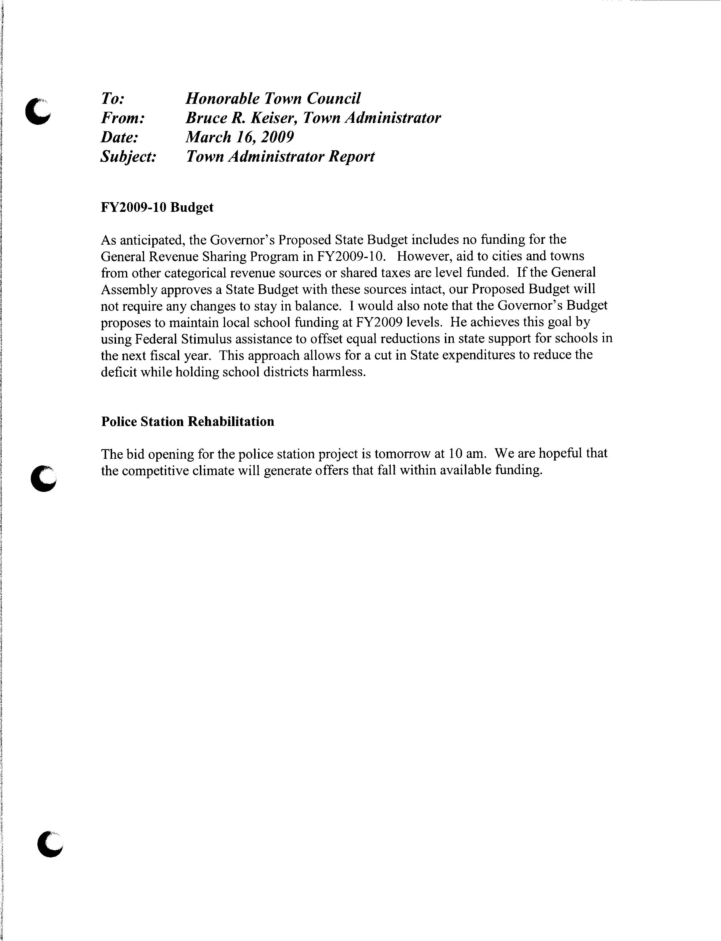

FY2009-2010 Budget
The Town Administrator stated that the Town’s spending plan will be presented to the Town Council for their review beginning on March 30.

The Town Administrator reported that at a meeting with the School Committee to discuss their budget proposal for education funding, it was mentioned that the Town is attempting to not increase taxes in the next fiscal year, given the economic climate. The plan is to be at or as close to a zero tax rate increase as possible.

The Town Administrator stated that on the town side he proposes to use a substantial portion of the undesignated fund balance to pay down principle on several of the town bonds to reduce debt service. The principle to be paid down is approximately $600,000, reducing debt service by approximately $280,000. This will offset increased expenses for town services; thereby lowering or allowing for a zero tax rate increase.

The Town Administrator noted that on the school side of the budget, assuming revenues remain level, predicted savings due to a decrease in Blue Cross costs, adjustment to Medicaid funding, possible pension plan reform, and freezing of non-contractual salaries, it is believed that the school can achieve an at or near zero tax rate increase as well.

Former Landfill
The Town Administrator reported that he and other staff members met with RIDEM, Department of Health and Dr. Ann Veeger to discuss future well sampling in the Jamestown Shores area. Dr. Veeger indicated that she would like to track as many wells of individual property owners as possible from the Shores area. This survey of wells would be done on a volunteer basis. Funding for the collection and well testing will be available from RIDEM. The results of the survey would provide information on the long-term environmental sustainability and development capacity of the Shores.

Council President DiGiando asked the Town Administrator to provide a three-year budget forecast to assist in understanding future challenges. The Town Administrator stated that he would include debt service, health benefits expenditures, and other variables.

- Finance Director’s Report
There was no Council action taken on the Finance Director’s Report.

- Jamestown Conservation Commission
  - Fort Getty Boat Ramp
  - Fort Getty Boat Ramp – proposed dredging
The Town Administrator reported that the Town Engineer is developing a plan to be submitted to CRMC regarding the access to the boat ramp at Fort Getty. The report will detail the intent to maintain fragile coastal features. The Town Administrator noted that the Conservation Chair has mentioned some provisions for special exceptions that we could utilize to determine if these improvements could be accomplished in Type I waters. In addition, it was thought that John Boothroyd, specialist in coastal features, could be invited to discuss potential adverse effects of this project. Mr. Boothroyd has volunteered to review the Town’s plan.

- Town Clerk re: meeting notices
  - Budget Work Session, Monday, March 30
  - Budget Work Session, Tuesday, March 31
No action taken on the notices.

PUBLIC HEARING

None

ORDINANCES AND RESOLUTIONS

1) Resolution re: April 2009, Fair Housing Month
It was moved by Councilor Szepatowski, seconded by Councilor White to adopt Resolution No. 09-004 entitled “April 2009, Fair Housing Month”. So unanimously voted.

COMMUNICATIONS AND PETITIONS

1) Letter from the Audubon Society of Rhode Island re: proposed dredging near Fort Getty
It was moved by Councilor Szepatowski, seconded by Councilor White to accept the letter from the Audubon Society of Rhode Island regarding proposed dredging near Fort Getty. So unanimously voted.

2) Invitation from City of Newport re: 53rd Annual St. Partick’s Day Parade, Saturday March 14
It was moved by Councilor Szepatowski, seconded by Councilor White to accept the invitation from the City of Newport regarding the 53rd Annual St. Patrick’s Day Parade. So unanimously voted.

3) Notification from Rhode Island Department of Environmental Management re: funding for projects eligible under the federal Clean Water Act through the American Recovery and Reinvestment Act (ARRA or the “Stimulus Bill”) (Responses are due by March 23, 2009)
The Town Administrator mentioned that the Town Engineer and Town Scientist attended a workshop regarding stormwater controls and eligibility requirements. At the present time the minimum project cap is $300,000. The Town does not have a project that fits into the eligibility parameters at this time.

It was moved by Councilor Szepatowski, seconded by Councilor White to accept the notification from RIDEM. So unanimously voted.

LICENSES & PERMITS
All approvals for licenses and permits are subject to the resolution of debts, taxes and appropriate signatures as well as, when applicable, proof of insurance.

- One Day Peddler License Application
Applicant: Lisa Kasabian dba: Nordic Design
55 Whittier Road, Jamestown
Location: Portuguese Citizen’s Club
Narragansett Avenue
Date: March 22, 2009 from 10 a.m to 2 p.m.
It was moved by Councilor Szepatowski, seconded by Councilor White to approve the One Day Peddler License for Lisa Kasabian dba Nordic Design for March 22, 2009 at the Portuguese Citizen’s Club from 10 a.m. to 2 p.m. So unanimously voted.

OPEN FORUM

- Scheduled request to address

None

- Non-scheduled request to address
Lisa Carlisle, West Passage Drive, read a statement in favor of the Lawn School improvement plan and in support of the School budget.

Arthur Christman, Windsor Street, asked that the Council send a message to the State regarding the Route 138 contamination of South Pond. The Town Administrator stated that in other discussions with RIDOT, the Town was assured that this is on the list of projects to be funded with stimulus money.

Mary Hall Keen, Carr Lane, spoke as a member of the Jamestown Education Foundation, reading a statement in support of the School budget as previously presented.

Beth Weibust, East Shore Road, stated that as an educator she supports the school budget. Ms. Weibust also supported no class size increases and no reduction in the arts. On another topic, Ms. Weibust asked if the mailboxes damaged by snowplowing on East Shore Road would be repaired. The Town Administrator noted that the State is responsible for the snowplowing on East Shore Road. Any claims should be made to the State.

Maureen Ryall, Columbia Lane, commented on the difference between zero percent tax increase versus zero percent budget increase. Ms. Ryall supported the school budget. She also addressed her concerns relating cutting school programs because of unfunded mandates.

APPOINTMENTS AND RESIGNATIONS

None

UNFINISHED BUSINESS

1) FAST Sailing Group re: Fort Getty draft lease
The Town Solicitor informed the Council that he expects to collaborate with the FAST Board on the continued efforts to draft a lease between FAST Sailing Foundation, Inc and the Town of Jamestown, for the development and operation of a sailing center at Fort Getty.

The Town Administrator reviewed the draft lease with the Council. Following are several concerns mentioned by Council members.
- Utility cost sharing.
- Boat trailer parking and the possibility of displacing recreational boating access.
- Concern with compatibility of uses.
- Detail of restrictions and plans needed.
- Size of area that FAST will be using, compared to the entire Fort Getty property.
- Request for map of entire site, specifically depicting the FAST site.

Council President DiGiando asked that continued discussion be held at the April 6, 2009 Town Council meeting.

2) Review of Boards, Commissions and Committees (no additional information at this time)
The Town Clerk noted that the following committees will be advertised to fill vacancies:

- Affordable Housing Committee
- Fire Department Compensation Committee
- Jamestown Emergency Medical Services
- Personnel Board
- Tax Assessment Board of Review
- Town Buildings and Facilities Committee

NEW BUSINESS

1) Verizon Communications and the Narragansett Electric Company re: relocation of one joint pole (P.2) 24’ easterly and place one new joint pole (P.3) as indicated on Plan on Elm Street
It was moved by Councilor Szepatowski, seconded by Councilor White to approve the relocation of one joint pole (P.2) 24’ easterly and place one new joint pole (P.3) as indicated on Plan on Elm Street. So unanimously voted.

There being no further business before the Town Council, it was moved by Councilor White, seconded by Councilor Szepatowski to adjourn the meeting at 7:55 p.m. So unanimously voted.

Attest:

Arlene D. Petit
Town Clerk

c: Town Council Members (5)
Town Administrator
Town Solicitor
Administrative Circulation

